Friday 22 August 2014

Strawberry Block - A Tutorial
After the joy of participating in my first swap I couldn't help joining in when The Strawberry Swap opened up on Instagram. I mean, strawberries! What's not to love! As part of my gift for this swap I drafted a large scrappy strawberry block (shown below) to use on a cushion and I thought it would be fun to share how I made it.
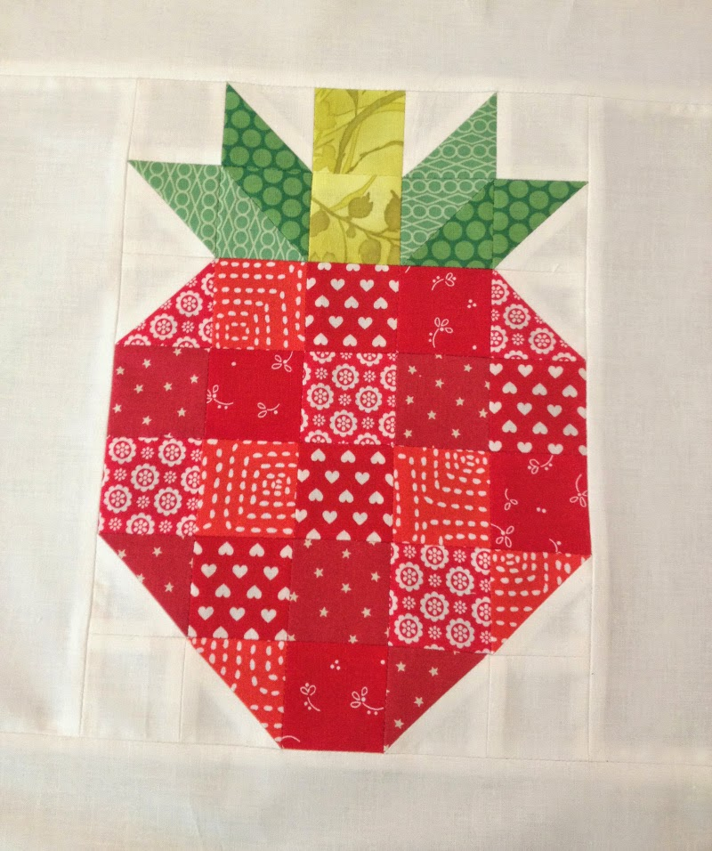
The best part about this block is it uses scraps! The pinks (or reds) can be cut from any number of different fabrics (I used 5). For the calyx (green bit) I used three different green fabrics (A, B, and C) to create the definition of the different leaves and stem. The block finishes at 7.5 in by 10.5 in.
Cutting:
PINK | GREEN | WHITE
17 x 2in squares  3 x 2.5in squares | 2 x 2.5in squares from print A  2 x 2.5in squares from print B  2 x 2in squares from print C | 4 x 2in squares  5 x 2.5in squares

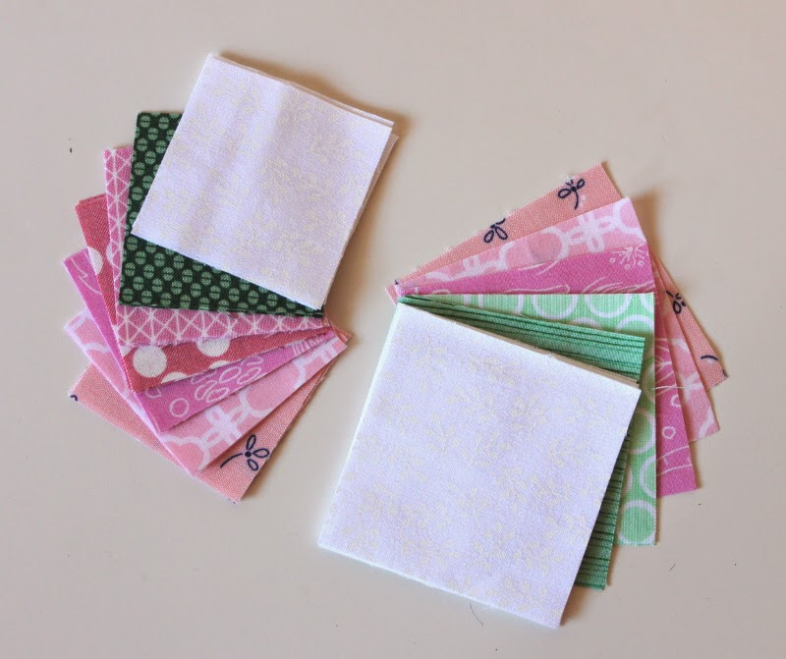
Assembly:
Our first job is to turn the 2.5 in squares into half square triangles (HST). Take the 5 white 2.5 in squares and one of the Green Print A 2.5 in squares and draw a diagonal line across each square from one corner to the opposite one.

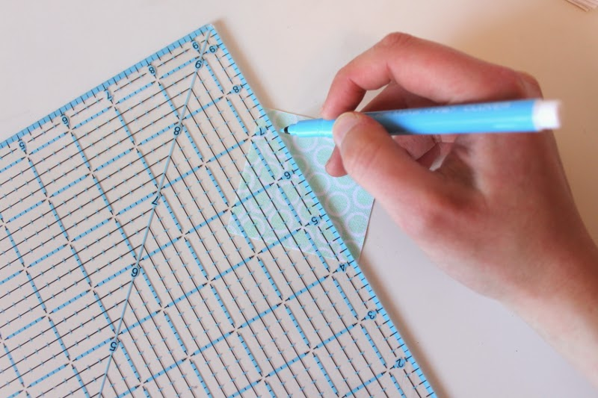
Pair the marked squares with the unmarked ones. NOTE: the marked Green Print A square should be paired with a Green Print B square.
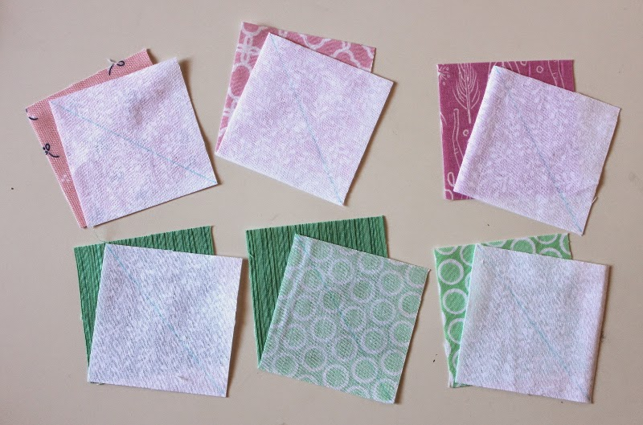
Sew the squares together a scant quarter inch from your guide line. When you reach the end turn the square around and sew a scant quarter inch from the guideline on the other side.
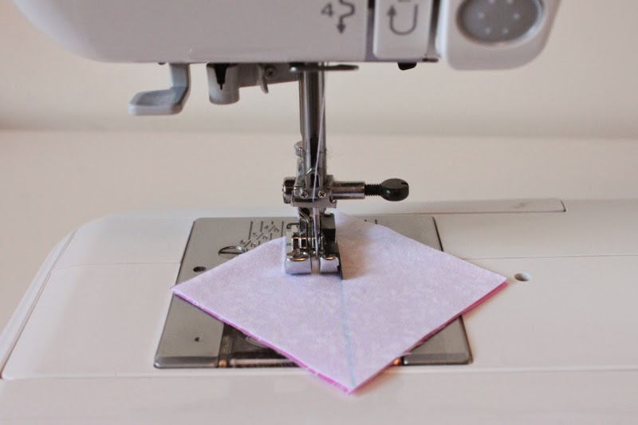

You should have two seam lines each a scant quarter inch from the guide line.
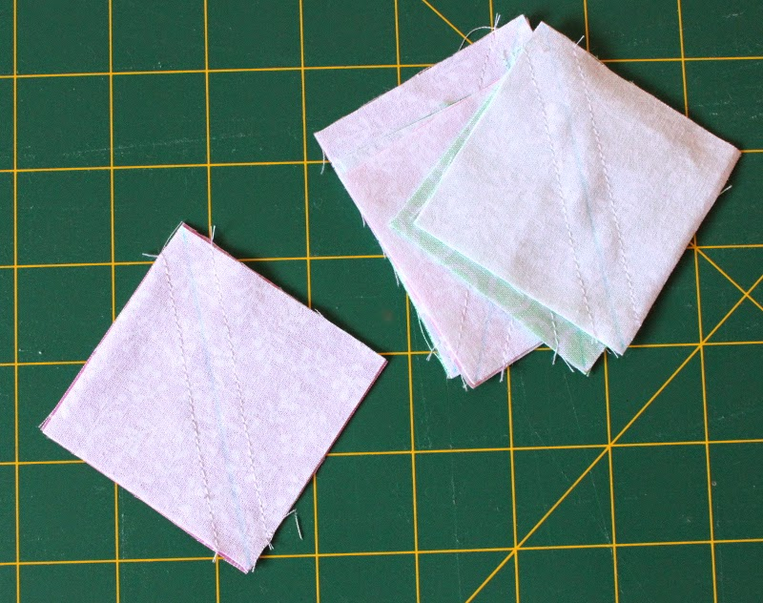
Cut along the guide line, dividing your square into two triangles each with a seam.
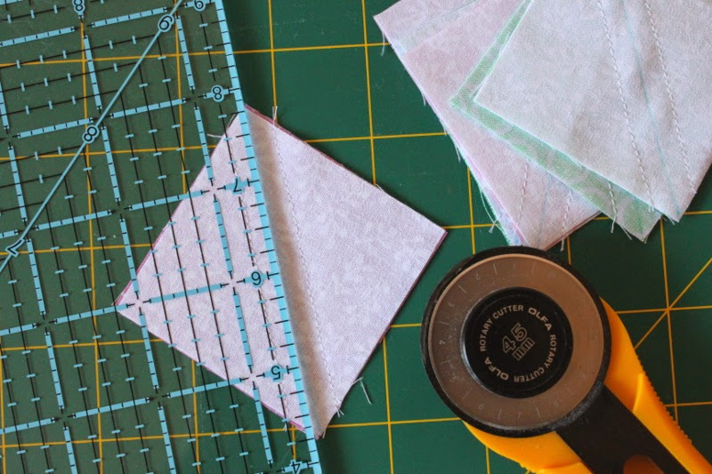
Press. I like to press my seams open as it keeps everything lying flat and keeps the seams from getting too bulky.
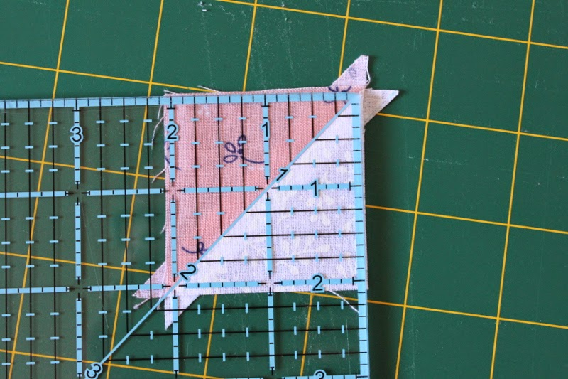
It's likely that your HST will be a little large so trim them down to 2 in square. Line up the 45 degree line on your ruler with the diagonal line of the HST and trim two of the edges.
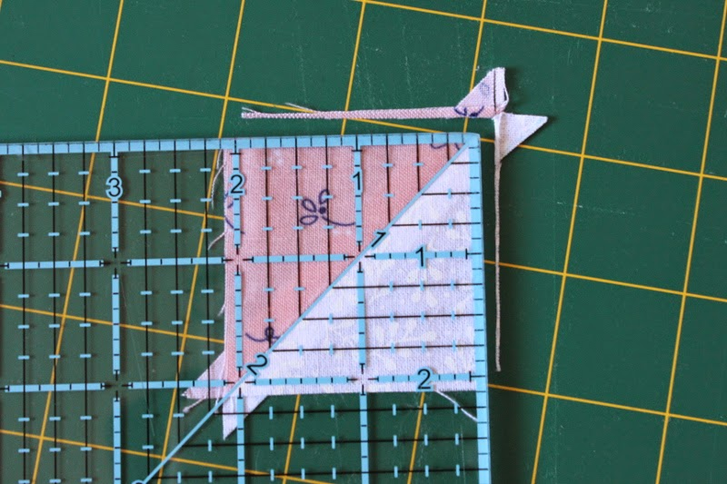
Rotate the HST 180 degrees making sure to line up the already trimmed edges with the 2 inch line on the ruler. Trim the remaining two edges.
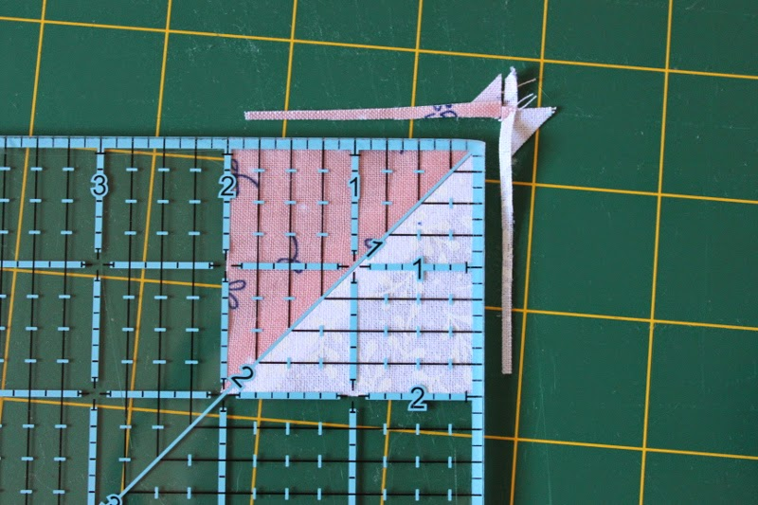
You should end up with 12 HST.
Arrange all 2 in squares and HST as shown in the picture below.
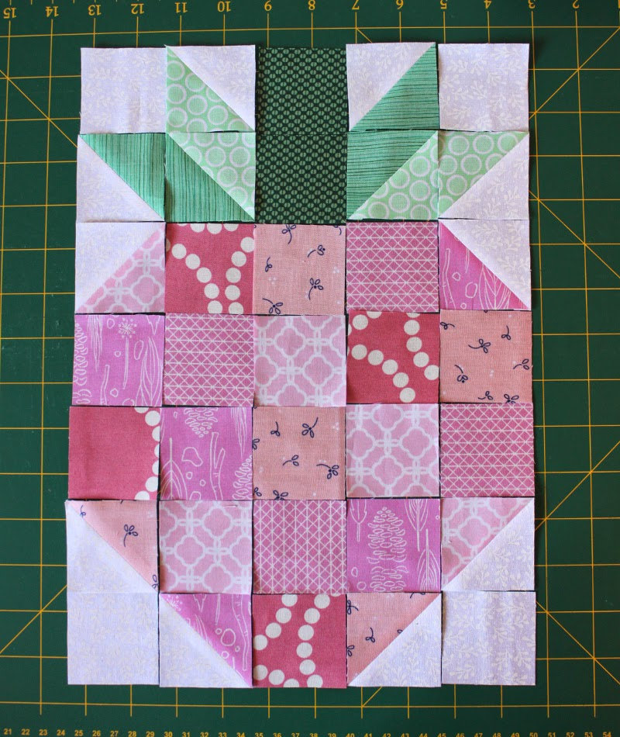
Assemble the block using a quarter inch seam. First sew the squares into rows and press the seams.
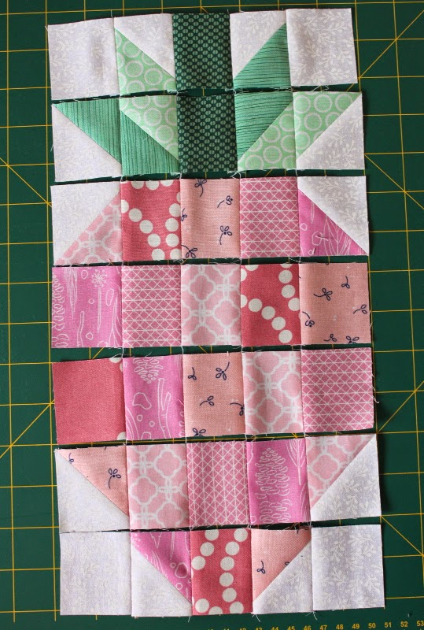
Then sew the rows together matching the seams in each row to create the final block. Press seams.
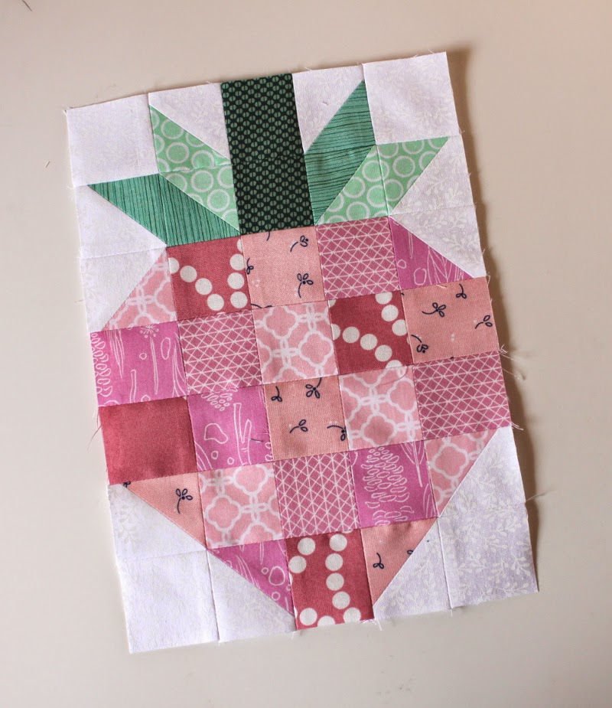
And you're done! If you have any questions please feel free to ask in the comments and I will answer there. If you do make a strawberry I'd love to see it. Leave a link to your finished block in the comments or if you post to Instagram tag me @skyberries. Enjoy!

